Asia-China-Coin-Bridge

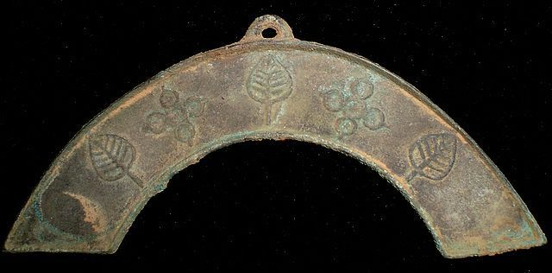 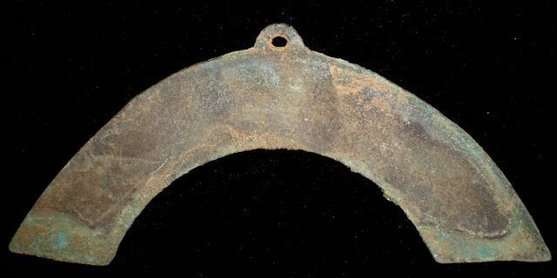

length 9.8 cm. /3.86 in., width 5.3cm. /2.09 in.

中型罄形币,just like the Shell Coin. One of the first coins in Chinese (even human) history. And at the same time, it is the unique coin in the world's coin history. It could be only used in china. We can hardly find the record about it in the history.

桥形币,Also called "Bridge Shape Coin". One type of coin which was used near the Capital of Zhou, Spring and Autumn Period. And at the same time, it is the unique coin in the world's coin history. It could be only used in china. There are many different shapes.

This collection is a very rare Bronze Bridge-shape Coin in Spring and Autumn Period.

# Spring And Autumn Period CURRENCY FLOWER LEAF STATUE MONEY BRONZE BRIDGE COIN桥形币4"

### Seller information

|  |  |
| --- | --- |
|  |  |

[bcculture](http://myworld.ebay.com/bcculture?_trksid=p2047675.l2559) ([79](http://feedback.ebay.com/ws/eBayISAPI.dll?ViewFeedback&userid=bcculture&iid=251407175063&ssPageName=VIP:feedback&ftab=FeedbackAsSeller&rt=nc&_trksid=p2047675.l2560) )

100% Positive feedback

[Follow this seller](http://www.ebay.com/itm/SpringAndAutumnPeriod-CURRENCY-FLOWER-LEAF-STATUE-MONEY-BRONZE-BRIDGE-COIN-4-/251407175063?nma=true&si=5L4Tlo08dyY9pQflhUEb6fWvMTI%253D&orig_cvip=true&rt=nc&_trksid=p2047675.l2557)

[See other items](http://www.ebay.com/sch/bcculture/m.html?item=251407175063&nma=true&rt=nc&si=5L4Tlo08dyY9pQflhUEb6fWvMTI%253D&orig_cvip=true&_trksid=p2047675.l2562)

Visit store:

[bcculture](http://stores.ebay.com/bcculture?_trksid=p2047675.l2563)

Top of Form

## Item Information

Item condition:

--not specified

“Rust on the body,Museum quality”

Ended:

Dec 26, 2013 07:21:34 PST

Winning bid:

US $9.99

[ [1 bid](http://offer.ebay.com/ws/eBayISAPI.dll?ViewBids&_trksid=p2047675.l2565&rt=nc&item=251407175063) ]

|  |  |  |  |
| --- | --- | --- | --- |
|  | Join **eBay Bucks** and earn **%** back on this item. [See conditionsfor eBay Bucks - opens in a new window or tab](http://pages.ebay.com/rewards/terms.html?ssPageName=STRK:VI:LNLK:TCS) | |  |
|  | | New customers get $10 back on 1st purchase Subject to credit approval.[See terms](https://apply.billmelater.com/apply?guid=1SJ8TEIO&assetId=NBRVI1213) | |

Shipping:

$10.00 Economy Shipping from outside US | [See details](http://www.ebay.com/itm/SpringAndAutumnPeriod-CURRENCY-FLOWER-LEAF-STATUE-MONEY-BRONZE-BRIDGE-COIN-4-/251407175063?nma=true&si=5L4Tlo08dyY9pQflhUEb6fWvMTI%253D&orig_cvip=true&rt=nc&_trksid=p2047675.l2557" \l "shpCntId)

See details about international shipping here.

Item location:

GuangZhou, China

Ships to:

Worldwide

Bottom of Form